**Simplifying Radicals**

Radical = Square Root

**Rules for Radicals:**

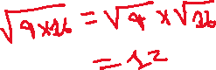

This does not work with addition and subtraction!

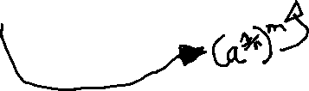

**Example.** Compute

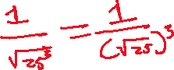

**Example.** Rationalize the denominator (Assume x represents a positive number.)

